The Gates of Dawn is one of the most visited shrines in Vilnius that is famous not only in Lithuania but also abroad, worshipped by the representatives of other creeds too. This is the only surviving gate of the first original five gates in the city wall that was built between 1503 and 1522.
The painting of the Blessed Virgin Mary, Mother of Mercy, in the Chapel of the Gates of Dawn is known all over the world. Many churches in other countries have copies of this painting. The picture, which is also called “Vilnius Madonna”, was painted in 17th century. It is painted in the Renaissance style, in tempera on oak boards, later repainted in oil. Since the middle of the 17th century it has been said to have miracle-working powers. The Holy Mother of God of the Gates of Dawn has been granted the title of Mother of Mercy twice.

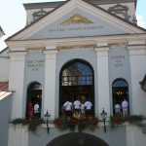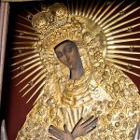
The church of St Anne is a masterpiece of the late Gothic period. There is no nonsensus about its originator or its construction period. Popular legend has it that Napoleon Bonaparte, who was fascinated by the beauty of the church, wanted to take it back to Paris in the palm of his hand. Unfortunately, the reality is not that romantic: during the march of the Napoleonic army through Lithuania, the church was consigned to the French cavalry forces. However, Napoleon did mention in a letter to his wife that „Vilnius is a very beautiful city“.

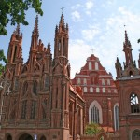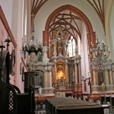
Vilnius University is one of the oldest universities in Eastern Europe. It was founded at a time when the reformation movement was active in Lithuania and Jesuit monks were invited to help fight the mood of reformation. Jesuit monks were quick to take over education. In 1569, they established a college and in 1579 the University of Vilnius was born.
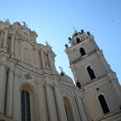

Užupis is sometimes compared to Monmartre in Paris or Christiania in Copenhagen. Užupis is a “republic” of artists. It has its own anthem, constitution, president, bishop, two churches, one of the oldest graveyards in Vilnius (Bernardine Cemetery), seven bridges, and a guardian (the bronze angel of Užupis). The constitution of the Republic of Užupis is displayed on a fence at the beginning of Paupio Street.
This is one of the oldest districts in Vilnius and is mentioned in historic documents as early as the 16th century.
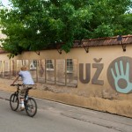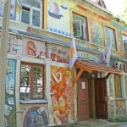
The Presidential Palace, called “Prezidentūra” (President’s Office) in everyday life, was built in the square of Simonas Daukantas (a graduate of Vilnius University and the author of the first history of Lithuania published in the Lithuanian language in the 19th century).
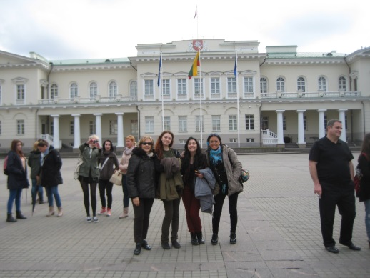

The Vilnius Castle Museum was opened in 1960, and in 1968 it became a subdivision of the Lithuanian National Museum. The exposition of the Vilnius Castle Museum displays reconstruction models of Vilnius castles of the second part of the 14th and the beginning of the 17th centuries, armament, iconographic material of old Vilnius. An observation deck on the top of the tower is the best place from which to appreciate a magnificent panorama of Vilnius.
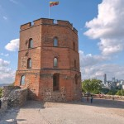

It is believed that The Three Crosses were first erected here in the 17th century to commemorate a group of monks from a nearby monastery, who were martyred in the 14th century. According to legend, seven were killed and seven were tied to wooden crosses and floated down the Neris River, with the instruction to return to the west from whence they had come. The monument has changed many times.
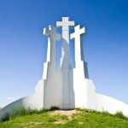
The Cathedral of St. Stanislav and St. Vladislav is the most important place of worship for the country‘s Catholics and the venue for the main Christian, folk and national festivities. In 1922, the Cathedral was granted the title basilica (meaning „royal“). This is the highest church category awarded by the Pope only to very special churches.
Many prominent people of the Lithuanian Grand Duchy – noblemen, bishops and dukes – are buried in the vaults of the Cathedral. The Sovereings Mausoleum located beneath the Chapel of St. Casimir contains the remains of the Grand Duke of Lithuania and King of Poland Alexander. He is the only ruler of Polan and Lithuania buried in Vilnius. Vytautas the Great, a grandson of Duke Gediminas and the most powerful Lithuanian ruler, is buried in the vaults of the Cathedral together with his wife Ona. Two wives of Žygimantas Augustas, Queen Elisabeth of Austria (Habsburg) and Queen Barbora Radvilaitė (said to have been the most beautiful woman of her time), are also buried here. The walls of the Cathedral also provide shelter for the urn with the heart of King Vladislovas Vaza (Wladyslaw Vasa).
The ancient wall of the temple dating back to the 13th-15th centuries, and the oldest Lithuanian fresco painted in the 14th century, have survived in the vaults of the Cathedral.

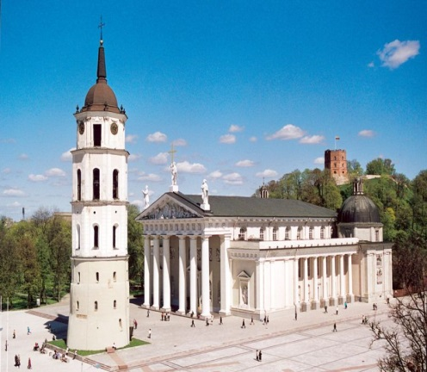

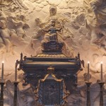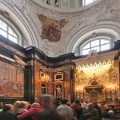

The Palace of the Grand Dukes of Lithuania, the former political, diplomatic, cultural center of the State, was one of the most famous in Europe in the 15th-17th centures and was demolished in the beginning of the 19th century. This Palace is excellent located just in the heart of Vilnius, within the confines of Lower Castle. Nowadays the Gothic, Renaissance and Early Baroque halls of this multifunctional Museum are ideally applicable to organize a different size and content public events, official visits, conferences, meetings, seminars, concerts, performances, receptions and other.
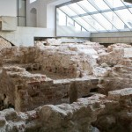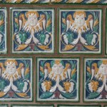

The old town of Trakai – which is extremely popular with the residents of Lithuania and foreign guests – is situated west of Vilnius between the hills, forests and lakes. The shores of the peninsula on which it is located are washed by the waters of Lakes Galvė, Totoriškių and Bernardinų (Lukos). This town, famous for its picturesque landscape and the legendary Trakai Castle, was a cradle of the Lithuanian statehood, an important military and political centre, headquarters of the Lithuanian Grand Dukes, and the capital of Lithuania.
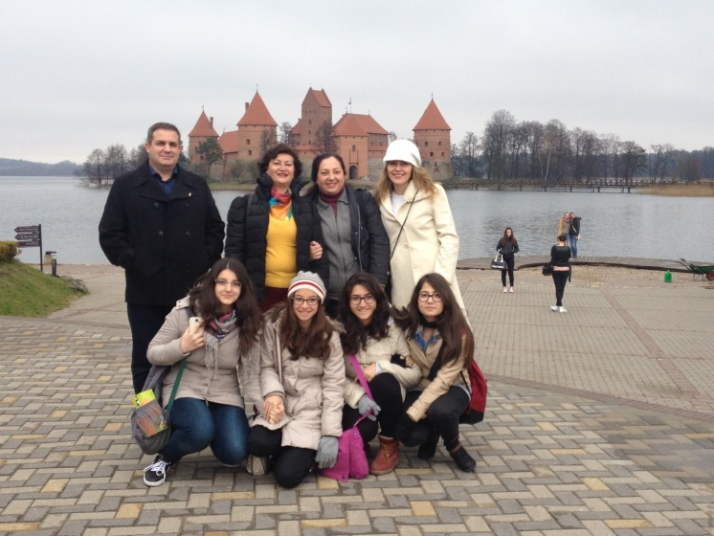
Trakai is also known for the Karaimes (a people speaking the Turkic language), who have lived there since the 14th century and have preserved their traditions. The kenesa – a Karaime sanctuary – and houses of Karaimes have survived in Trakai, and the national dishes (the most popular is kybyn – a small pasty stuffed with minced meat) of this ethnic group can be tasted at the Karaime Restaurant.
